Challenge of the day

Question:-i)create a cloudfront distribution with s3 bucket(using step functions)

ii)create a certificate and validate the certificate (using step functions)

iii)associate the certificate to the distribution(using step functions)

step1:- go to the step function service drag the service called “request the certificate(cloudfront)”

here the main issue is creating a certificate at different region can’t be associated with the distribution.so,created in the northvirginia (us-east-1) then we can easily associated with the distribution

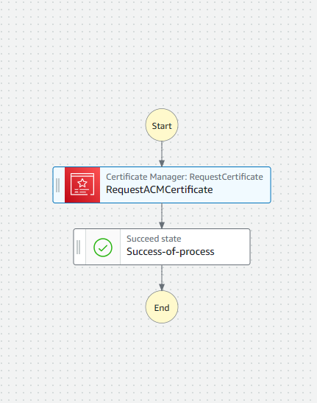

Code githublink:- [**https://github.com/praneethmanchem/stepfunctions.git**](https://github.com/praneethmanchem/stepfunctions.git)

step2:-go to the step function service drag the service called create a distribution

update the parameter to the requriments

next drag the service CloudFront: CreateInvalidation (The **CreateInvalidation** API call in AWS CloudFront is used to create a new cache invalidation for a specified CloudFront distribution.)

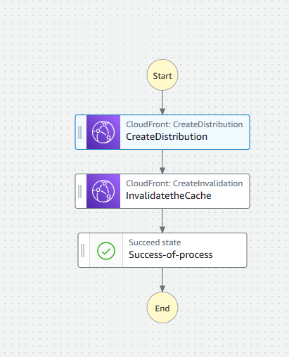

Step3:- Here we need to add the arn of the certificate issued in the us-east-1 to this process

Before that you need to have the domain in route 53 or godaddy and you need to add or update the record that is generated in the us-east-1

Code githublink:- [**https://github.com/praneethmanchem/stepfunctions.git**](https://github.com/praneethmanchem/stepfunctions.git)

Manual things:- need to create the oai (origin access identity)

Need to attach the policy to the s3 to get access for that objects in the bucket(index.html)

Task finished